CONFIDENTIAL

GAP Assessment Audit Agenda

Site address:
Hyderabad, Telangana 502307
Date Planned: 08/07/2019 to 12/07/2019

Company Representative (on Behalf Of ): M/S.PHARMQA COMPLIANCE SERVICES

1.G.Sundar-Quality compliance –Director/Consultant and Inspector
2.DR Murugan - Independent Consultant and Inspector

LIST OF CONTENTS
1.0 Objective
2.0 Scope
3.0 Schedule
4.0 Supporting Documentation
5.0 Assessment Standards
6.0 Proposed Agenda
7.0 Reporting
The following is a plan for the Audit to be conducted by M/S.PharmQA Complaince services on behalf of XYZ Pharmaceuticals Pvt Ltd for the period of.This audit 08/07/2019 to 12/07/2019 will be focusing on the company’s general GMP;QC Lab; compliance status for the manufacturing and laboratory; packaging of Drug products and to assess the compliance level and also to their future business compliance w.r.t respective market registered products in / EU /USFDA/WHO and PIC(S)
1.0 OBJECTIVE
The objective of the audit is to evaluate the level of current compliance of the facility and its manufacturing and packaging operations in line with international regulatory requirements. (USFDA/EUGMP/ICH Q7/PIC(S) and WHO TRS)
2.0 SCOPE
The audit will focus on the activities and systems involved in the manufacturing, packaging, Quality control, testing, warehousing, engineering, water systems and release of Finished pharmaceutical products manufactured at the facility Major scope of the inspection covers verification of Data integrity and its compliance requirements.
3.0 SCHEDULE
We anticipate arriving at the facility at approximately as per working hours of the facility. We request you to cooperate the extended hours (if needed)
4.0 SUPPORTING DOCUMENTATION:
We request availability of the following reference and discussion materials during the course of this audit: but not limited to.
- Site Master File and/or Quality Manual /VMP
- GMP, manufacturing, ISO or other certification
- List of products manufactured at the site
- Current Organisation Chart for the site.
- Facility floor plans
- Procedures to prevent mix-up and cross contamination in production and packaging
- Plans of Air handling (HVAC), Compressed air system, and any other service systems supporting packaging.
- Index of SOPs.
- Job descriptions for Key personnel
- Training schedule and records
- Data Integrity Compliance-Complete assessment in QC and QA ;laboratory Documentation ;Electronic Records verification in HPLC;GC;UV and IR and other Wet Lab instruments
- Data Integrity Compliance-Complete assessment in QMS Documentation
- OOS; OOT;OOE and lab incidents
- Change Control-key CCF to be reviewed.
- Procedures for rework/reprocessing
- Reference and working standards of RM; API and PM
- Analysis controls-Specifications and Test Methods-RM ;In-process and Intermediates and finished API and packaging Materials
- API;RM; Excipients; PM vendors and its controls
- Stability study and controls-Review of Protocol and stability reports.
- Recording of deviations and follow up
- Annual Product Review SOP and Review of APQR/PQR
- Quality Metrics Trends
- Validation Master Plan for the site registered.
- Validation Reports-Process validations and Analytical Method validations.
- Qualification/Validation Reports for production equipment and Process areas
- Cleaning Validation Reports for equipment and areas used for production
- IT Department and its controls
- Register for All QMS documents
- Risk assessment
- Environmental monitoring summaries (trending) for packaging areas used for packaging
- Procedures, systems and reporting on audits to be conducted for suppliers
- Vendor Audit and certification procedure for suppliers of materials used in manufacturing and packaging.
- Internal audit schedule
- Handling of complaints and recalls
- Training systems and its compliance-Analyst and Other Departments
- Calibration Program-QC and Other departments
- Preventative Maintenance Program-QC and other departments
- Microbial laboratory –Review of Complete Process from sample receipt; Sterilization ;inoculation ;Media and culture controls.
- Computer system validation and software validation
- Trainings review

All the applicable areas of 6 cGMP systems get audited
5.0 ASSESSMENT STANDARDS:
The review will be conducted in line with ICH Q7; USFDA API inspections; EU GMP and WHO GMP and Data Integrity Compliance standards
6.0 PROPOSED Agenda:
Introduction

- Introduction of Company management and its facility changes after USFDA inspection
- Brief introduction of PharmQA Compliance services
- Discussion of audit objective, plans, and schedule- Review of EIR and Audit report by USFDA
- Overview of general site and facilities design and layout
Key Audit Process
- Facility tour of receiving, storage, sampling, dispensing, manufacturing, packaging, warehousing and shipping areas, following with material and personnel flow.
- QC Laboratory tour and microbial laboratory
- Quality systems: oos; management review, documentation system, internal audit, training, change control, deviation management, Risk assessment validation approach, corrective and preventive action.
- Data Integrity Inspection in detail in QC instrumentation and IT
- Environmental monitoring review
- Calibration and maintenance program
- Validation master plan and reports review
- Complaints and recall management
The scope of inspection to be extended including ETP and material transport system (to assure GDP and distribution) and Utilities.
Concluding Meeting (At final day)
- Review of any issues arising during the audit
- Discussions

7.0 REPORTING:
A report will typically be issued within15 days of completion of the audit. A written response including a corrective action plan to address any recommendations is requested within 30 days of your receipt of the audit report.
We look forward to visiting your facility .Do not hesitate to contact me if you require additional information or further clarification of any of these issues.

Business card:
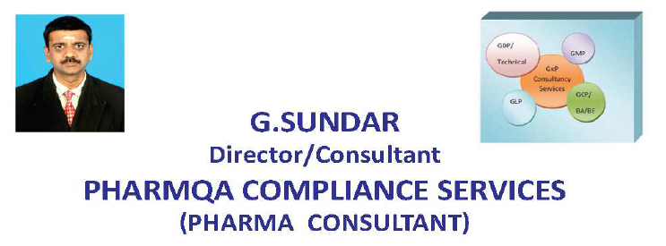
Plot No B304-TVSEMERALD GREEN ACRES
GANDHI ROAD; KOLAPAKKAM
CHENNAI-600127Email id:Sundarganesan73@gmail.com
Sundar73@rediffmail.com
Phone:+917799588440;+917799588441

We are the registered firm under scientific and technical consultancy services section D of MSME scheme and our registration Number:. UAN:TS02D0004251

Visit Us: URL: https://www.linkedin.com/in/g-sundar-a3b39610

Thanks and Regards
G.SUNDAR -Director/Consultant
PHARMQA COMPLIANCE SERVICES

